**Lab Exercise 14- LCD 16X2 and Ultrasonic Sensor using Arduino**

Here's a **lab exercise** to interface a **16x2 LCD display** and an **Ultrasonic Sensor (HC-SR04)** with an Arduino to measure the distance and display the result on the LCD.

**Components Needed:**

1. **Arduino Uno** (or compatible board)
2. **16x2 LCD** (with or without I2C)
3. **HC-SR04 Ultrasonic Sensor**
4. **Potentiometer** (if not using I2C for the LCD)
5. **Breadboard** and **jumper wires**

**Circuit Diagram:**

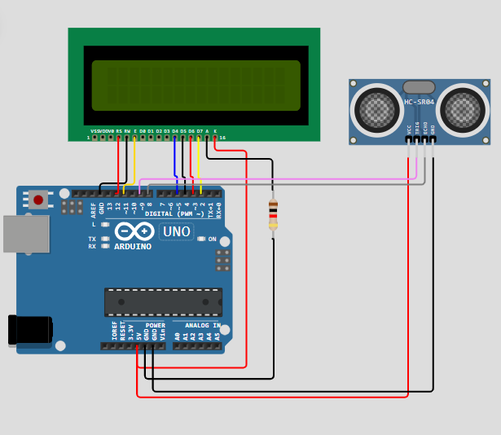

**Arduino Code:**

#include <LiquidCrystal.h> // includes the LiquidCrystal Library

LiquidCrystal lcd(12, 11, 5, 4, 3, 2); // Creates an LCD object. Parameters: (rs, enable, d4, d5, d6, d7)

const int trigPin = 9;

const int echoPin = 8;

long duration;

int distanceCm, distanceInch;

void setup() {

lcd.begin(16,2); // Initializes the interface to the LCD screen, and specifies the dimensions (width and height) of the display

pinMode(trigPin, OUTPUT);

pinMode(echoPin, INPUT);

}

void loop() {

digitalWrite(trigPin, LOW);

delayMicroseconds(2);

digitalWrite(trigPin, HIGH);

delayMicroseconds(10);

digitalWrite(trigPin, LOW);

duration = pulseIn(echoPin, HIGH);

distanceCm= duration*0.034/2;

distanceInch = duration*0.0133/2;

lcd.setCursor(0,0); // Sets the location at which subsequent text written to the LCD will be displayed

lcd.print("Distance: "); // Prints string "Distance" on the LCD

lcd.print(distanceCm); // Prints the distance value from the sensor

lcd.print(" cm");

delay(10);

lcd.setCursor(0,1);

lcd.print("Distance: ");

lcd.print(distanceInch);

lcd.print(" inch");

delay(10);

}